Diwali Sales Analysis

The following insights were acquired by performing Exploratory Data Analysis (EDA) on the given dataset using Python. This analysis involved summarizing the main characteristics of the data through various statistical graphics, discovering the relationship of varying factors with the amount of sale taken place.

1. **Age group & Gender**

The following section provides insights into sales patterns categorized by age group and gender. By analyzing these demographic factors, we aim to identify trends and preferences among different segments of the population. This analysis will assist in optimizing sales strategies and improving customer targeting.

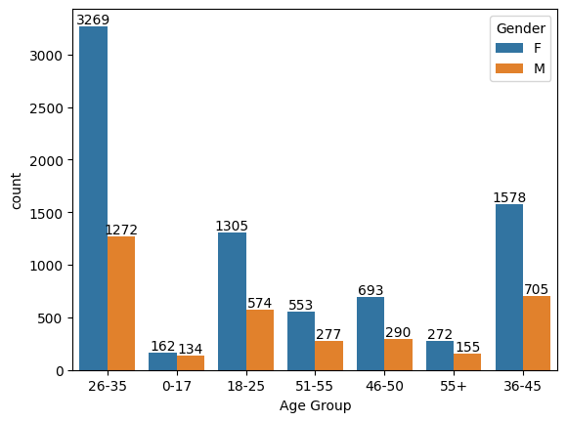

**Inference:**

From the above graph, it can be seen that females of age 26 to 35 form most of the buyers segment.

1. **Marital Status**

The following section provides insights into sales patterns based on marital status. By analyzing how marital status influences purchasing behaviour, we aim to identify key trends and preferences among different customer segments. Here, ‘0’ represents unmarried and ‘1’ represents married.

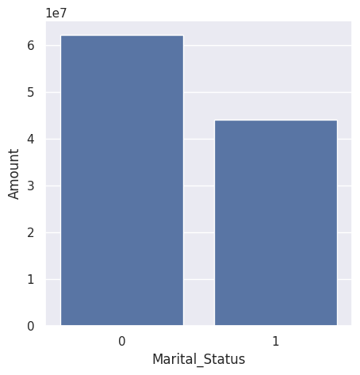

**Inference:**

From these graphs, we can see unmarried buyers are more than married buyers.

1. **States**

The following section provides insights into sales patterns across different states. By analyzing regional sales data, we aim to uncover geographic trends and preferences. This information will help in tailoring regional marketing strategies and optimizing distribution channels to better serve our customers in various locations.

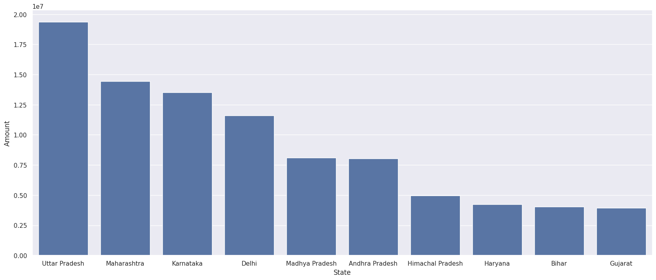

**Inference:**

From the above graph, maximum sale has come from the states of U.P., Maharashtra, Karnataka and Delhi.

1. **Occupations**

The following section provides insights into sales patterns based on occupation. By examining how different professions influence purchasing behaviour, we aim to identify key trends and preferences among various occupational groups. This analysis will assist in developing targeted marketing strategies and customizing product offerings to better cater to the needs of our diverse customer base.

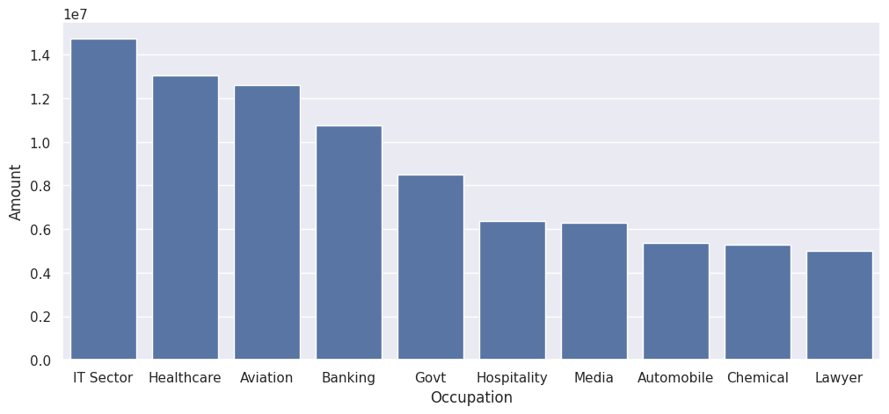

**Inference:**From the graph above, buyers are majorly from:

1. IT Sector
2. Healthcare
3. Aviation
4. Banking

**Final Conclusion:**

Our analysis for Diwali sales reveals that the majority of buyers are females, particularly those aged 26 to 35, who also account for the highest spending. Sales are predominantly from the states of Uttar Pradesh, Maharashtra, Karnataka, and Delhi. Unmarried buyers exceed married buyers, and the main occupations of our customers are the IT sector, healthcare, aviation, and banking.